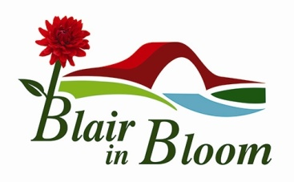

Minutes of Annual General Meeting held on Tuesday 15 February 2022
at Rattray Bowling Club

Present: Mary Birch, Cllr Bob Brawn, Ian Cruickshank, Pat Lumsden, John Mclean, Morag Reid, Janine & Phil Seymour, Avril & William Wilson, Jean Smith, Steve Johnson, Lesley McDonald, Sam Stewart

Apologies
Cllr Caroline Shiers, Tracie Dick, Sheena Shepherd
Minutes of 2020 AGM
Approved – William Wilson
Seconded – Janine Seymour
Matters Arising
None
Treasurer’s Report
The accounts for 2021 were circulated showing a balance of £17,407.07. However a total of £15,500 is ring-fenced for Rattray Community Garden for the installation of utilities.
It was noted that from Equipment & Signage the sum of £998 should have been listed as insurance for the ATV.
Annual Report for 2021
The Annual Report was circulated and is attached to this Minute. A brief pictorial history of the year was shown as a PowerPoint presentation by Mary Birch.
Election of Office Bearers & Committee
Chair – Mary Birch (proposed Janine Seymour, seconded Morag Reid)
Vice Chair – Janine Seymour (proposed Mary Birch, seconded Pat Lumsden)
Treasurer – William Wilson (proposed Ian Cruickshank, seconded Janine Seymour
Committee – Ian Cruickshank, Pat Lumsden, Morag Reid, Phil Seymour, Avril Wilson (proposed Jean Smith, seconded Janine Seymour)
New Committee Member – John McLean (proposed Mary Birch, seconded Pat Lumsden)
AOCB
- The Amendment to Constitution paragraph 10, Dissolution & Disbursement of Surplus Funds, was agreed to state that surplus funds be passed to Blairgowrie & Rattray Development Trust.
- Adoption of Equal Opportunities Policy drawn up in October 2021 was agreed
Demonstration of Website
A comprehensive demonstration of Blair in Bloom’s new website was given by Steve Johnson and it was agreed that this will now go live as soon as possible. Phil Seymour agreed to be the administrator of the site for Blair in Bloom.
Thanks were expressed to everyone who attended and the meeting closed at 8pm.

